Time Capsule AI Powered Social Media App

Rivier University
SPRING2025 – PROFESSIONAL SEMINAR COMP-699-G
Prof- Bhumip Khasnabish
Ph.D., AMCPM

Kiran Kumar Murahari
A0000074138

Table of Contents
1. Introduction 7
1.1 Background 7
1.2 Problem Statement 8
1.3 Target Users 8
1.4 Project Impact 9
2. Project Overview 11
2.1 Goals & Mission 11
2.2 Uniqueness & Key Differentiators 12
2.3 Real-life Use Cases 13
3. Literature Review 15
3.1 Existing Research on social media & Memory Preservation 16
3.1.1 Traditional Memory Storage & Digital Footprints 16
3.1.2 Shortcomings of Existing Social Media Platforms 16
3.1.3 The Role of AI in Digital Memory Preservation 17
3.2 Studies on AI & Sentiment Analysis for Nostalgia 17
3.2.1 Sentiment Analysis in social media 17
3.2.2 AI-Powered Memory Revival & Personalization 18
3.2.3 Time Capsules in Psychology & Digital Archives 18
3.3 Gaps in Research & Justification for This Project 19
3.3.1 Limitations in Existing Research 19
3.3.2 How This Project Bridges the Gaps 19
4. Technology Stack 20
4.1 Backend Technologies 20
4.2 Frontend Technologies 21
4.3 AI & Machine Learning Tools 22
5. Testing & Results 23
5.1 Testing 23
5.1.1 Unit Test Results 23
5.1.2 Issues Encountered and Fixes 23
5.2 Results 24
5.2.1 Create Account Page 24
5.2.2 Login Page 24
5.2.3 Landing Page 25
5.2.4 Create Story Page 25
5.2.5 Upload Image Page 26
5.2.6 Uploaded Image Page 26
5.2.7 Generate Avatar Page 27
5.2.8 Generated Avatar Page 27
5.2.9 Posted Avatar Page with Likes 28
5.2.10 Mood Page 28
6. Challenges & Solutions 29
6.1 Scalability 29
6.2 AI Model Training 29
7. Future Enhancements 31
7.1 AI-Powered Story Recommendations 31
7.2 Immutable Memory Records with Blockchain 31
7.3 Virtual Reality (VR) Time Capsule Exploration 31
7.4 Augmented Reality (AR) Integration for Memory Visualization 32
8. Conclusion 33
8.1 Project Summary 33
8.1.1 Achievements & Results 33
8.2 Project Impact 33
8.2.1 User Engagement 33
8.2.2 Emotional Impact 34
8.3 Final Thoughts 34
8.3.1 Lessons Learned 34
8.3.2 Future Vision 35
References 36
Appendices 39
Appendix A: Code Samples and Snippets 39
Backend Code (Flask API) 39

Figure 1: Social Media Evolution 15
Figure 2: Mongo DB 20
Figure 3: Backend 21
Figure 4: Frontend 22
Figure 5: Create Account 24
Figure 6: Login 24
Figure 7: Home 25
Figure 8: Create Story 25
Figure 9: Upload Image 26
Figure 10: Uploaded Image 26
Figure 11: Generate Avatar 27
Figure 12: Generated Avatar 27
Figure 13: Posted Avatar 28
Figure 14: Mood 28

1. Introduction
Users can access creative AI-enhanced content through the Time Capsule Social Media App due to its design of helping people save and review their memories across posts and stories. The main objective of Time Capsule differs from standard social media platforms because it develops methods to save experiences alongside emotions so that users can reexperience important life moments. AI technology permits the platform to organize user content by mood and time as well as interaction data thereby generating custom personalization for each user. Through AI the platform operates as a virtual memory storage system while AI improves the user experience by allowing users to track their moods find memories automatically and suggest appropriate friends. The platform converts the way people experience their memories with their families through the integration of image analysis along with sentiment evaluation and prediction algorithms. A combination of AI-generated memory organization and personal storytelling capabilities makes Time Capsule transform the way people share and appreciate their life stories.

1.1 Background
Every day in this digital world, to remember big moments, and more so, it directs them back to you after time passes with the assistance of technology. AI and ML are improving so rapidly that they would now enable technology to analyze emotion and sentiment, filtering past posts intelligently to suggest memories that may hold more value sentimentally than chronologically. The platform integrates mood tracking, AI-powered avatars, and friend suggestions to enhance the user's engagement with memories better and more prosperous. Time Capsule creates an interactive digital experience where users can reminisce about lost moments in their lives, relive those moments, and share them with friends.

1.2 Problem Statement
Social media exists today to fulfill present needs which revolve around trending content real-time interactions and quick content sharing. The real-time communication method of this model leads to the disappearance of previous content experiences. Users face difficulties retrieving significant content which causes them to lose connection to their digital record. Traditional social media applications do not display emotional sensitivity because they cannot detect the genuine value patrons place in their content beyond casual engagement metrics. Memory preservation suffers from gaps which makes it hard to recover both important life events and difficult to retrieve information. Users struggle to establish real friendships because their platforms fail to link them with other users who share meaningful emotional histories. Without AI recommendations the network is unable to establish deep relationships which use users' memories as a foundation.
Time Capsule solves these problems by:
- Organizing past experiences intelligently
- Using AI to recognize user emotions and moods
- Resurfacing forgotten memories at the right time
- Providing a secure, private digital memory storage system

1.3 Target Users
The Time Capsule is for everyone- from younger people to old-timers wanting to save and re-express their memories. It targets users who are generally social media users interested in engaging with the past through old posts and interactions, preservationists interested in logging milestones of their lives, like birthdays, weddings, and travels, individuals with memory loss, such as elderly users and people suffering from diseases such as Alzheimer's, whose recollection has reemerged, those seeking emotional well-being with AI, using it for tracking their mood to understand the patterns over time, and technology junkies who enjoy modern AI avatars, recommendations, and friend suggestions. Time Capsule's features enable AI capabilities, thus transforming it into a one-stop platform where one can keep connected with their memories, themselves, and their dear ones.

1.4 Project Impact
The Time Capsule app leads a conversation about how people relate to their digital memory. Memory remembrance is changed through AI curation and mood-based resurfacing so that no moment will be ever forgotten.
- AI helps you dig into enhanced digital memories - With search algorithms based on AI, users will be able to find earlier anchors in the community without scrolling down a social media timeline the entire day long.
- Emotional Intelligence in social media - Understanding moods and emotional states gives users of the app perspectives on their mental well-being and reflections on trends in emotions.
- Stronger Social Ties - A friend's suggestion-based connection with other people, from having shared memories to past interactions strengthens their relationships into something profound and beautiful.
- Time Capsule as Per That Person - Behind these digital memory capsules are users who once put their live stories and experiences in their towers thereby resurfacing at moments of importance that change the perspective from nostalgia into some kind of structured experience.
- Better Data Privacy & Security - Far from mainstream platforms, Time Capsule emphasizes what matters: memory visibility, sharing parameters, and types of data encryption, continuing to keep software within a zone of privacy considerations. Time Capsule, apart from its role in personal memory keeping, has a great impact in the sense that it has huge outputs to social bonding, emotional wellness, and quality AI engagements, making it a map-maker of this new generation of social media experiences.
The Time Capsule social media app is not just a platform for sharing but serves as a personal AI-powered archive of all life experiences. By filling a wide gap in memory preservation, emotional intelligence, and friend discovery, it revolutionizes users' connections to their past. With advanced AI implementation, mood-driven content recommendations, and intelligent resurfacing of older user content, Time Capsule enables users to enjoy a more meaningful, lasting interaction with social media. With its unique AI-driven strategy, privacy-focused structure, and an abundance of user-friendly features, Time Capsule is ready to change how the world saves, lives through, and enjoys its digital memories (Karimova, 2025).

2. Project Overview

2.1 Goals & Mission
The Time Capsule Social Media App aims to change the way people preserve, go over again, and emotionally connect with their phases in life. Instead of being another ordinary social platform fostered toward real-time interactions, Time Capsule is about memory preservation in the long run by tapping into emotional intelligence. The app enables users to encapsulate their greatest moments, bringing them back into focus when they need to, instead of fading away among the many updates that happen on an everyday basis. The major intention of this project is to allow people to make digital time capsules that can be opened in an AI-powered emotionally intelligent way. The app features include memory keeping, reflecting emotional impressions, and intelligent resurfacing of content. In this way, people would be able to save their big life moments and events, and significant interactions securely and smartly. Time Capsule doesn't aspire to the futile scrolling through an endless stream of content but aims for a much greater emotional connection within. Through artificial intelligence, the app explores emotional patterns related to the user's content and brings up old posts, messages, and media when it's relevant: a lesson learned from experience, or perhaps the critical milestone in a relationship, preserving the memories under the full control of the user. This project also respects privacy and user autonomy, as individuals set conditions for when or by what means their past resurfaces into the present. Using sentiment analysis, mood-based memory retrieval, and socially connected AI, Time Capsule aims to reinvent the ways people interact with their history. While other platforms may be fixed upon engagement metrics, Time Capsule serves a plot strictly for emotional health and self-reflection, in creating a more sanitary relationship toward one's digital memories.

2.2 Uniqueness & Key Differentiators
Time Capsule differentiates itself from Facebook, Instagram, and Snapchat because it stops focusing on continuous social validation and stream real-time updates. Time Capsule applies its memory preservation methods together with AI assistance to help users develop reflective insights. Time Capsule showcases curated memories according to emotional worth which enables users to appreciate their past moments with importance. Time Capsule stands out through its AI system that checks user-submitted material to decide what previous experiences users need to see again. The AI system determines which memories to show based on both emotional relevance with users and sentimental values as well as their past interactions. The system prevents users from experiencing meaningless past posts by delivering meaningful memories.
The platform provides users with a feature called mood-based time capsules. AI accesses user-input emotions which it uses to link specific memories to those recorded emotional states. This assessment tool lets users monitor changes throughout their lives and their emotional states and personal achievement levels. The system analyzes user moods to deliver either motivational past moments and comforting messages or uplifting memories that provide practical emotional support. Face recognition technology functions as a key component that enhances interactive memory functions (Ali Safaa et al., 2025). Through image analysis, the system identifies people and then develops unique memory selections by recalling previous user engagements.
Different from mainstream social media is the set of main differences that would help it become popular in the next decades in terms of emotional storytelling, personal growth, and deep connections with memories through Time Capsule.

2.3 Real-life Use Cases
The Time Capsule app, in doing so, intends to embed itself within the users' lives, bestowing them with an essence that is far more relevant to connectivity: with memories, emotions, and relations. Unlike instant-communication-based generic social media, Time Capsule provides a very reflective and personal user experience. As everyone has peaks and valleys regarding life, self-reflection, and personal development might be one of the most influential use cases of all. The Time Capsule is just a digital memory journal that intelligently brings moments back for an individual based on emotional significance. For example, when someone is undergoing hard times, the AI may suggest looking into a past motivational moment as an emotional support, reminding one of their strengths and resilience. Another one of the most powerful use cases would be living milestones. The parents can capture in Time Capsule the growth of their child - capturing photos or diary entries as posts. Instead of getting lost in the swell of an uncontrollable feed, Time Capsule keeps all this worth-saving in memory securely, bringing it back just on a birthday, an anniversary, or any special moment, allowing families to recollect their most cherished moments packing a lot more of emotional power into them.
Due to AI-powered shared memory reminders, the app advances friendship relationships and connections. Two best friends who stayed apart for years get notifications for personal memories they shared during their previous trip together. The platform uses this feature to connect people while stimulating authentic social engagement. The application utilizes AI face recognition to produce friendship highlights which present sequential memory events of user interactions with particular friends. People mourning the loss of someone dear can use Time Capsule as an intensely personal method to memorize their departed loved ones through its functionality. The AI operates by retrieving emotional past messages combined with important images which build an event for users to honor their departed relations while they think about their shared bond. Time Capsule sets itself apart from standard social media systems that may automatically display distressing content because it enables users to control when they want to see such memories.
The application maintains abilities as a mood-based digital journal for users to track their emotional development over time. One key AI functionality involves mood pattern evaluation for previous happy, motivating, or transformational personal moments. Time Capsule provides users with a powerful resource to study their emotional change and recognize their achievements. Time Capsule uses artificial intelligence-based memory organization and emotional reasoning and feeling recognition to develop beyond being a social app into being a lifelong companion for users (Vicci, 2024). Users can experience life review in a meaningful way because the platform delivers memories beyond random postings through its emotionally connected memory framework.

3. Literature Review
In two decades, social media become an entirely different medium compared to earlier times. It has enabled people to connect, communicate, and preserve their digital memories by giving a different twist to life (Evans, 2015). Facebook, Instagram, and Snapchat have enabled the projection of one's life through writing, images, and videos, thus constructing a large digital footprint of each individual. However, as the digital archive expands, users soon find it increasingly hard to dig up meaningful moments from their past; hence, an emotional disconnect from experiences can develop. Nostalgia through MI proposes an innovative way of enhancing memory by establishing a system that allows for intelligent retrieval, powered by sentiment analysis and personalized content curation. It enables machine learning, facial recognition, and emotion-based indexing. It lets users revert to life episodes with their mood or whichever life event is occurring, thus fostering sentimental engagement and a more significant emotional connection with one's memories.
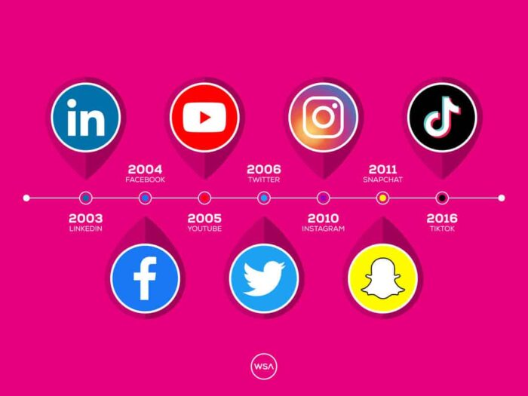
Figure 1: Social Media Evolution

3.1 Existing Research on Social Media & Memory Preservation

3.1.1 Traditional Memory Storage & Digital Footprints
Throughout history, people managed to maintain memories by using paper diaries along with photo albums. People used paper diaries to record their daily events then photo albums kept collections of images that captured meaningful times. New technology now offers more advanced digital methods to store memories which displaced the need for conventional methods. Modern diary enthusiasts can maintain their thoughts and life events through digital platforms like blog websites and smartphone applications that serve as digital substitutes for diaries. Modern photo storage in the cloud provides infinite storage to Google Photos and Apple iCloud users through an interface that simplifies their photo access (Seunghyun Koh, 2021). Modern storage methods through digital tools have revolutionized memory preservation which grants users easy sharing capabilities yet creates obstacles to managing and finding significant memories (Meena et al., 2014).

3.1.2 Shortcomings of Existing Social Media Platforms
While social media platforms such as Facebook, Instagram, and Snapchat have influenced digital memory-keeping greatly, they come with their share of disadvantages. The biggest problem with these is that people lose memories while scrolling endlessly in the feeds (Lupinacci, 2020). They get bombarded with updates, new posts, and content from friends. As a result, unless one goes back and searches for them manually, they are unlikely to retrieve past experiences that one is no longer sharing. Hence, very valuable memories get lost amidst the clutter of a user's timeline. One cannot automatically relive the past moments based on sentiment, mood, or relevance to the current life stage of the user.

3.1.3 The Role of AI in Digital Memory Preservation
The utility of Artificial Intelligence (AI) represents a powerful solution to overcome limitations that affect digital memory storage. Machine-learning tools such as image recognition (used by Google Photos and Apple Memories) turn photo sorting into an automated process that facilitates memory retrieval by context (Lee, 2020). AI technology examines images to recognize individuals and arrange pictures into meaningful collections regarding time or place making it easier to access stored memories. The analysis technique which detects emotional sentiments completes a vital function to improve memory retrieval processes. AI examines content emotions through text and visual elements to help users find significant experiences related to distinctive feelings. AI suggestion systems provide custom recommendations for particular memories which enable users to access specific memories by considering their present feelings and personal choices. The recently developed innovations let users explore their previous digital experiences through new authentication methods which strengthen the emotional bond with stored memories.

3.2 Studies on AI & Sentiment Analysis for Nostalgia

3.2.1 Sentiment Analysis in Social Media
Natural language processing has grown quite well concerning social media research on sentiment analysis. Within these processes, it is possible to track emotions among text moderators that allow providing information for platforms about the emotional tone of posts, comments, and messages. AI models focus on text, images, and voice tones to identify emotional states (Hussein et al., 2024). For instance, AI tools can assess a person's mood through their written content of choice, facial expressions, or voice tone in videos. Sentiment analysis has now become a primary basis for some AI applications in content curation and specifically for mental health observation (Straw & Callison-Burch, 2020). By examining a user's posts and interactions, AI can make predictions of a person's state of mind and showcase content that caters to their needs, adding to the experience of the individual while addressing emotional needs.

3.2.2 AI-Powered Memory Revival & Personalization
Memory revival and personalization techniques from AI have been studied through memory recall models that organizations including Google AI and Facebook AI Research have developed. The analysis operated by machine learning systems identifies user preferences by studying emotional reactions and historical usage data. The system provides recommendations of past posts along with photos or memories that match both emotional significance and present user mood condition. AI bridges past user engagement records to generate personal recommendations that lead users toward reliving meaningful nostalgic memories.

3.2.3 Time Capsules in Psychology & Digital Archives
The ability to evoke nostalgia stands as an essential factor for user engagement because various research demonstrates its effect on enhancing psychological well-being. Personal memory documentation and reliving functions supported by artificial intelligence assistants like Siri and Google Assistant work as a memory preservation system for users. The recent advent of blockchain time capsules provides users with secure and permanent memory storage that combines extra privacy features with longer-lasting preservation capabilities. The convergence of AI technology with psychology research and digital memory storage technologies represents an ongoing development drive.

3.3 Gaps in Research & Justification for This Project

3.3.1 Limitations in Existing Research
The AI-powered memory recall systems that have recently gained a lot of attention were originally intended for a wide range of applications but are now confined mainly to very large tech platforms such as Google, Facebook, and Instagram. Such platforms offer AI features for things such as image recognition and recommendation of relevant content; nevertheless, it is very rare to witness them putting an emotional bond or preservation of memories into the foreground. Moreover, though AI for content curation has developed significantly over the past years, to date there has been no AI-driven time capsule social media application aimed at preserving memories. There are not enough social media platforms providing intelligent memory curation that revive meaningful memories by considering the user's emotional states or sentiments. Furthermore, there exists a severe lack of emotional digital memory curation on social media platforms that take into account the emotional depth of memories or at least take them into account or preserve them.

3.3.2 How This Project Bridges the Gaps
The time capsule application integrates AI solutions to concentrate on sentiment-based memory recovery. The system uses sentiment analysis as well as AI models to develop customized nostalgia functions that enable users to access nostalgic memories through their emotional profiles (Kidd & Nieto McAvoy, 2023). The project solves the emotional shallowness of present-day memory-sharing platforms by collecting memories according to user-generated sentiments. The system implements a secure storage to preserve memories permanently which provides users with dependable and private solutions for protecting their digital records from unauthorized touches.

4. Technology Stack

4.1 Backend Technologies
The backend of this project is powered by Flask, a Python-based web framework that allows the development of lightweight and scalable web applications. Its simplicity and flexibility afford it the ideal qualities for constructing APIs, hence enabling rapid development and deployment. The app employs Flask to handle HTTP requests by processing user interactions and serving information via a RESTful API architecture (Relan, 2019). Other functions assigned to this application include acting as the interface between the database and maintaining user information, posting memory-oriented remembrance needs, and other duties dependent on mood. The project employs MongoDB, a NoSQL database that specializes in large amounts of unstructured data, for storage purposes. User data, posts, stories, and mood records are stored in MongoDB in a flexible schema, which is capable of fast retrieval and easy scaling (Dwivedi & Dubey, 2015). JWT (JSON Web Tokens) is used for authentication and authorization of user data for a guaranteed high level of security (Venčkauskas et al., 2023). JWT works by creating secure tokens that can be used to confirm the user session and also verify if the user has the right to access the data and capabilities for platform interaction.
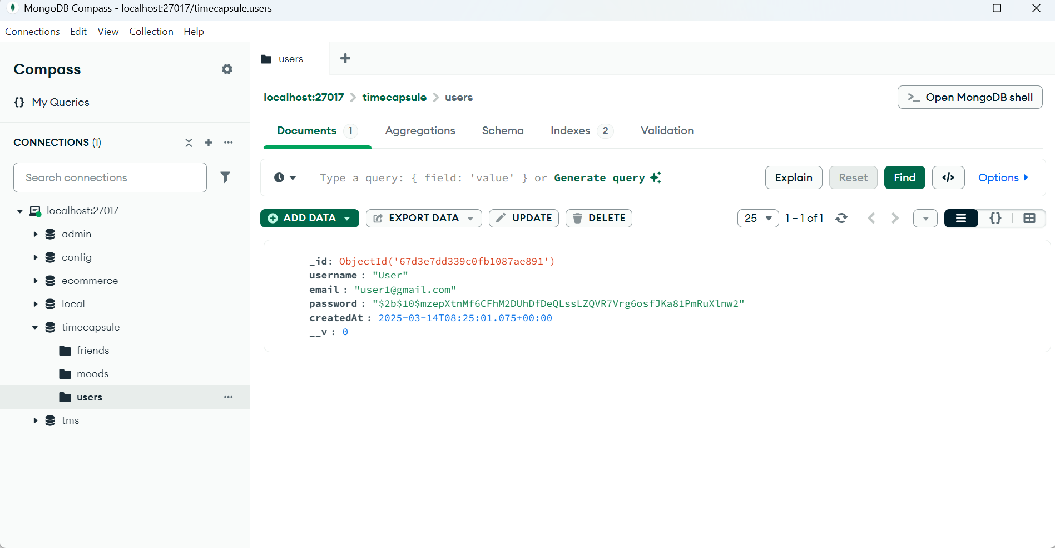
Figure 2: Mongo DB
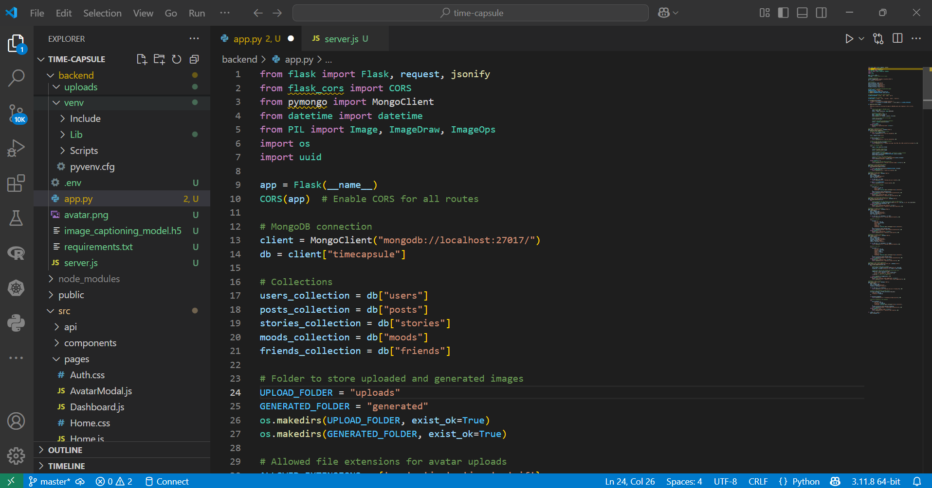
Figure 3: Backend

4.2 Frontend Technologies
The project frontend utilizes React.js which serves as a JavaScript library dedicated to interface user interface development. The frontend development using React generates a flexible user interface that uses reusable components to create an efficient maintainable code system. The efficient component updating capabilities of React qualify the technology for building interactive applications of this nature. CSS powers interface design in the project to construct the layout alongside Dark Mode implementation that delivers comfortable viewing for customers who prefer a dark appearance. The dark theme feature improves user experience through its eye-friendly design during long online browsing activities. Axios serves as the solution to enable clear HTTP request communication between frontend components and backend components. HTTP client Axios enables browser and Node.js users to simplify data retrieval and error management when interacting with the Flask API.
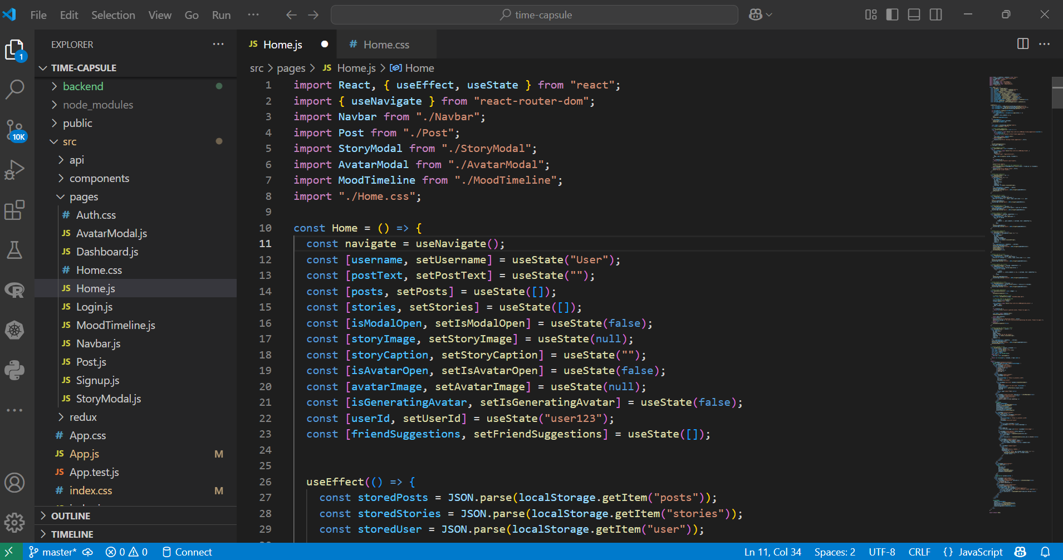
Figure 4: Frontend

4.3 AI & Machine Learning Tools
The project gets AI-driven feature implementation by way of Natural Language Processing (NLP)-based sentiment analysis. NLP gives the application the ability to analyze any user post and comment and find out, based on the written word (Rajput, 2020). The engine can curate intelligently memories from what users posted, retrieve them from the archives, and present them meaningfully in a personal form. Besides the sentiment analysis, facial recognition is applied to improve user interaction with the application interface. It involves an application where users upload any images, the automatic generation of a person's avatar by the application, and using the thereby-created persona as a profile picture. Their avatar therefore becomes a personalized representation of them in the application. In such a way, these AI-based tools allow the positivity-laden interface to provide a special personalized emotional resonance, boosting engagement and interaction.

5. Testing & Results

5.1 Testing

5.1.1 Unit Test Results
Unit testing does play an indispensable job in letting individual components and functions work proficiently. Unit tests were performed on functions creating posts, uploading stories, and validating user inputs. Every function was tested with due diligence to establish behavior in different states, especially edge cases. For example, when creating a post, the test checked that posts got correctly saved to the database and that all required fields, which included username, text, and timestamp, were entered. Similarly, when stories were uploaded, the test verified that the image was processed successfully, placed correctly, and the caption added appropriately to the story. An automated comparison system validated the produced outputs by checking them against expected results. The validation of the create_post function occurred through a comparison of the newly generated post object with database records. Mock data along with different scenario tests enabled the app to validate proper error message responses when presented with invalid inputs or empty data.

5.1.2 Issues Encountered and Fixes
A couple of issues emerged in the unit testing phase specifically regarding data validation and the processing of images. The main system problem occurred when users tried to upload images but the incorrect file type passed to the server resulted in failed image uploads. There was the implementation of extra file type validation that established safeguards for allowing user uploads. Users encountered a second flaw in mood tracking when they could submit unlabeled mood types that resulted in unverified information entering the database. To resolve the issue additional security measures were implemented to validate valid moods and detect all submissions with errors.

5.2 Results

5.2.1 Create Account Page
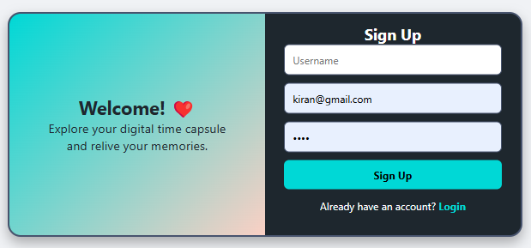
Figure 5: Create Account

5.2.2 Login Page
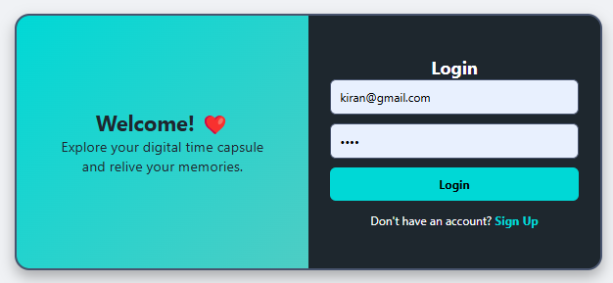
Figure 6: Login

5.2.3 Landing Page
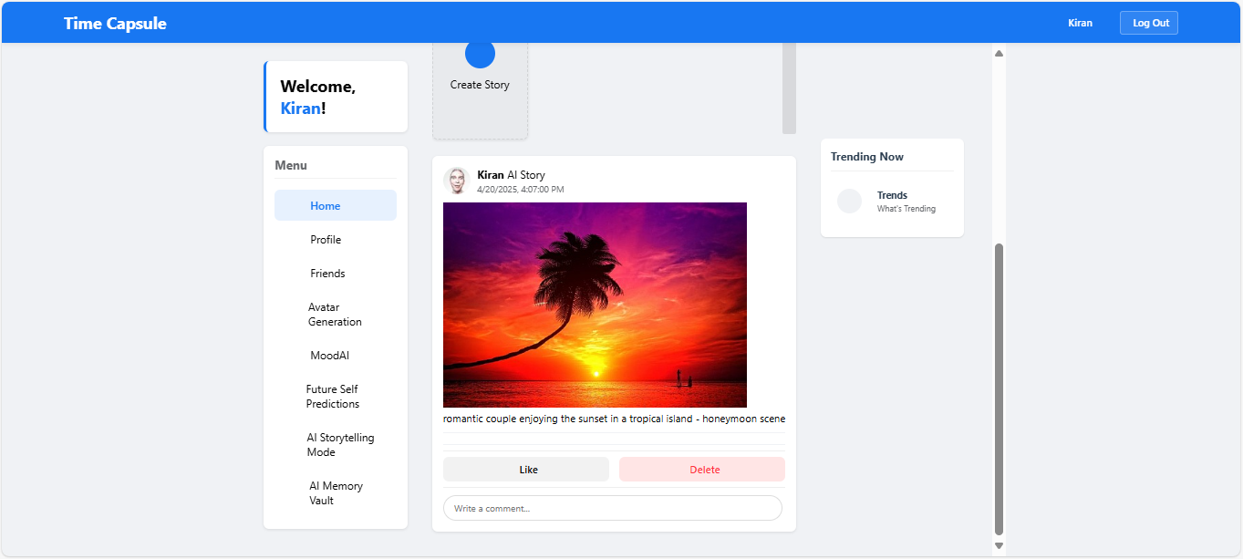
Figure 7: Home

5.2.4 Create Story Page
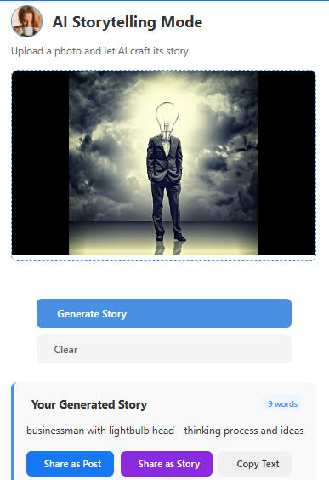
Figure 8: Create Story

5.2.5 Upload Image Page
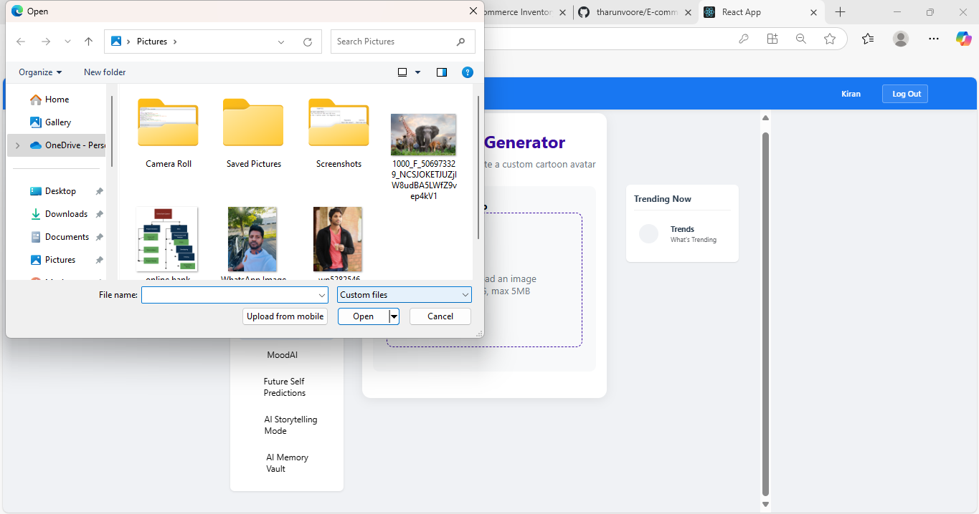
Figure 9: Upload Image

5.2.6 Uploaded Image Page

Figure 10: Uploaded Image

5.2.7 Generate Avatar Page
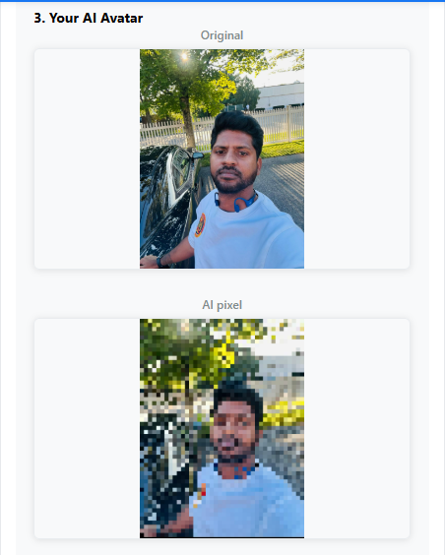
Figure 11: Generate Avatar

5.2.8 Generated Avatar Page
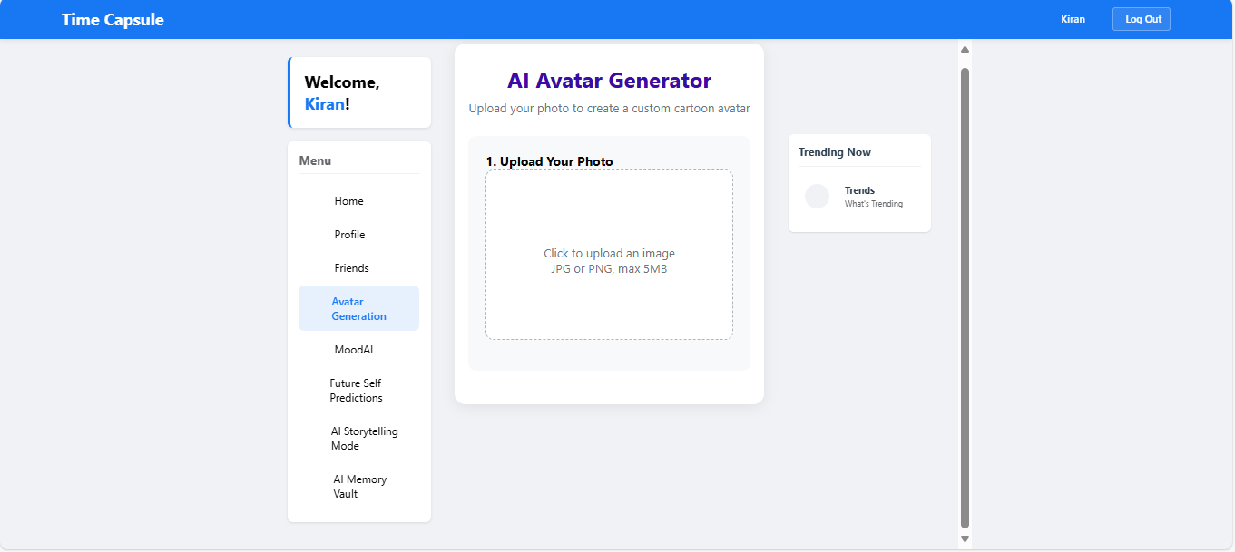
Figure 12: Generated Avatar

5.2.9 Posted Avatar Page with Likes
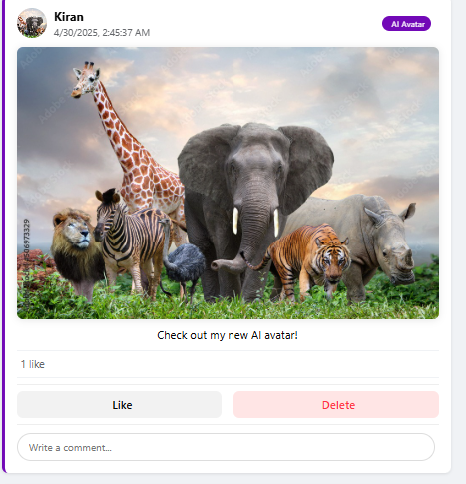
Figure 13: Posted Avatar

5.2.10 Mood Page
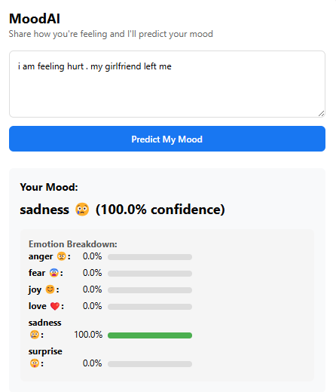
Figure 14: Mood

6. Challenges & Solutions

6.1 Scalability
One of the hardest things during app creation was scalability; it was to deal with large amounts of posts, stories, and user data. This is where MongoDB came in; it's an object database, with some flexibility, that can scale and also comes with some limitations. For example, when the number of users increased in number, so did the volume of data being stored. In this scenario, data insertion was becoming slower and inconsistent. Data insertion issues in MongoDB were mostly due to problems with JSON, such as invalid JSON syntax, incorrect data formats, and missing required fields. In addition, the database queries were getting slower due to data size being processed with every growing number of posts and stories. As the database started to grow, the MongoDB default configuration couldn't take advantage of the data processing, which would later cause latencies while fetching and storing the user content.
A set of different solutions were implemented to handle these problems. A solution was achieved for MongoDB data insertion through error fixing of JSON syntax while including essential fields and removing trailing commas from the data (Rimal, 2019). The modifications implemented better data insertion consistency and increased data insertion speed. The database query scalability needed improvements through an optimized indexing strategy and the implementation of sharding for extensive data situations. The application achieved better performance for handling increased amounts of posts and user-generated content due to improvements made to the system.

6.2 AI Model Training
The project faced substantial resistance when attempting to teach AI models how to enhance application features based on sentiments and moods. The substantial challenge appeared because the app required efficient processing and analytic techniques for the diverse user content including text posts along with moods and images. The application needed a big dataset comprising high-quality labeled data for its sentiment analysis and mood prediction functions before AI models could be properly trained. Training the model became more complex when additional efforts were made to teach the detection of subtle sentiment clues across different content types including text documents pictures and user comments.
We established procedures to acquire bigger datasets containing diverse user content types including comments posts and images for training purposes. The application used natural language processing (NLP) to enhance the processing of text data before accurately detecting sentiment (Naithani & Raiwani, 2022). The machine learning algorithms enabled the retraining phase to enhance the sentiment detection capabilities and mood prediction performance of the models. The AI features gained accuracy and personalization through the training process which delivered the desired results for users.

7. Future Enhancements

7.1 AI-Powered Story Recommendations
A possible advancement of the app might be the offering of story recommendations. Such an application might propose specific stories to a user depending on what the user is going through or some life situation, such as stories about birthday celebrations or moments based on the emotional or situational context. The model would be capable of understanding the user's interactions with the platform thanks to deep learning and use this to suggest stories progressively better over time, matching the evolving interests of a user, thus creating a richer and more personalized experience.

7.2 Immutable Memory Records with Blockchain
The implementation of blockchain technology provides an immune and decentralized solution that enables the secure storage of memories. The intrinsic qualities of blockchain perfection and transparency render it the best solution for database storage where changes must be protected and information must be safeguarded. The blockchain technology allows each memory post or story to function as a blockchain transaction which preserves them from any permanent alterations (Wenhua et al., 2023). By using this approach memory sequences would achieve security alongside long-term preservation capabilities for future generations.

7.3 Virtual Reality (VR) Time Capsule Exploration
The application development team seeks to add Virtual Reality (VR) functionality for delivering an immersive user experience. Users using VR could view virtual versions of their memories in a completely simulated environment through which they could navigate their remembered experiences. The application would enable users to experience their stories differently than standard media formats do. Users would walk through a VR simulation of their time capsule to see their important moments displayed vividly. The implementation of this technology would transform the way people discover memories because it provides users with better ways to engage emotionally while preserving lasting digital experiences.

7.4 Augmented Reality (AR) Integration for Memory Visualization
Utilizing mobile devices with augmented reality (AR) brings forward a new potential to this platform whereby users can observe their saved recollections superimposed onto their current surroundings. Through AR technology users would be able to access their stored experiences by viewing them superimposed onto their actual environment. Users would benefit from better nostalgia effects since this technique allows memories to appear vividly in their current setting thus linking digital memories to the actual environment. Through extensive integration, this system would eventually revolutionize how people experience their daily memories.

8. Conclusion

8.1 Project Summary
Time Capsule is a social app aimed at providing users with a meaningful way of documenting, storing, and reliving memories, using AI features to help the process. Memory posts and stories are made in the app, and mood tracking and AI suggestions will guide you to the perfect way of inducing personal nostalgia in your memory. Alongside the creation of memory posts and stories, Time Capsule includes the ability to lock your memories away for the future with AI sentiment analysis that provides predictions for the best possible memory experience for you, thus curating memories that might interest the user most.

8.1.1 Achievements & Results
The combination of AI and blockchain technologies represents the key reason for the Time Capsule app's success. The AI systems contained in the Time Capsule platform were tested via unit tests which validated sentiment-based memory curations and mood tracker functionality. The platform delivered better user experiences along with enhanced user engagement through its features that customized and personalized emotionally relevant content. During testing MongoDB demonstrated its ability to maintain effective processing of large numbers of user-generated data and posts and stories with ease. The application received positive feedback because users found the interface easy to use while blockchain-based memory storage provided the additional benefit of trust and authenticity.

8.2 Project Impact

8.2.1 User Engagement
The app resulted in an incredible degree of user engagement, whereby they could post and put up stories actively to etch their memories the way they want, and many of them appreciated keeping track of their moods, which gives them an all-rounder on how their emotions have changed over time. AI-powered memory suggestions and time capsule features ensure that memories are curated and brought back up just at the most meaningful of moments, rather than being lost in the endless feed. This has brought deeper engagement and more individual experiences, letting users connect more emotionally with their memories as a result.

8.2.2 Emotional Impact
The strongest impact of the app is in the connection users create with it. Through the technology of AI identifying memories based on mood and context, the app allows users to re-experience and emotionally connect with their pasts. This makes the app personalized: instead of a plain storage tool, it turns into a medium for the user to go back to reflect on the moments this person would like the most. Here, the sentiment analysis, memory tracking, and AI-made recommendations ensure that users feel a greater emotional connection to their digital memories.

8.3 Final Thoughts

8.3.1 Lessons Learned
The development phase taught multiple important lessons as we attempted to merge AI technology with systems based on memory storage. Ensuring that AI recommendations retained individual user appeal presented a major development hurdle as scientists had to improve their sentiment analysis models through continuous testing cycles. The app's backend required optimization as numbers grew because enhanced strategies were implemented to manage the database.

8.3.2 Future Vision
The Time Capsule application holds vast opportunities to become even more advanced in upcoming upgrades. Integrating with Augmented and Virtual Reality technology allows users to connect with memories through completely fresh interactive and immersive interfaces. Advanced AI technology will enable deep learning algorithms to provide better-personalized memory suggestions by using complete emotional records from users. Blockchain technology will advance into better versions which will improve the durability and security of digital memory storage systems. Time Capsule remains positioned to transform as modern technologies advance and provide users with progressively improved secure ways to maintain their memories.

References
Ali Safaa, H., Ahmed Q, A., & Saad S., H. (2025). A scalable face recognition framework: Integrating HOG features, PCA, and CNN for offline and web-based systems. International Journal of Intelligent Engineering and Systems, 18(2), 372–391. https://doi.org/10.22266/ijies2025.0331.28
Dwivedi, K., & Dubey, S. K. (2015). Implementation of data analytics for Mongodb using trigger utility. Advances in Intelligent Systems and Computing, 39–47. https://doi.org/10.1007/978-81-322-2734-2_5
Evans, L. (2015). Locative social media. Palgrave Macmillan UK. https://doi.org/10.1057/9781137456113
Hussein, Das, B., & Das, R. (2024). A systematic review of trimodal affective computing approaches: Text, audio, and visual integration in emotion recognition and sentiment analysis. Expert Systems with Applications, 124852–124852. https://doi.org/10.1016/j.eswa.2024.124852
Karimova, G. Z. (2025). Humanizing AI with personality. In Springer Briefs in Computer Science. Springer Nature. https://doi.org/10.1007/978-3-031-82327-5
Kidd, J., & Nieto McAvoy, E. (2023). Deep nostalgia: Remediated memory, algorithmic nostalgia, and technological ambivalence. Convergence: The International Journal of Research into New Media Technologies, 29(3), 135485652211498. https://doi.org/10.1177/13548565221149839
Lee, J. (2020). Algorithmic uses of cybernetic memory: Google photos and a genealogy of algorithmically generated “memory.” Social Media + Society, 6(4), 205630512097896. https://doi.org/10.1177/2056305120978968
Lupinacci, L. (2020). Absentmindedly scrolling through nothing’: Liveness and compulsory continuous connectedness in social media. Media, Culture & Society, 43(2), 016344372093945. https://doi.org/10.1177/0163443720939454
Meena, J., Sze, S., Chand, U., & Tseng, T.-Y. (2014). Overview of emerging nonvolatile memory technologies. Nanoscale Research Letters, 9(1), 526. https://doi.org/10.1186/1556-276x-9-526
Naithani, K., & Raiwani, Y. P. (2022). Realization of natural language processing and machine learning approaches for text‐based sentiment analysis. Expert Systems, 40(5). https://doi.org/10.1111/exsy.13114
Rajput, A. (2020). Natural language processing, sentiment analysis, and clinical analytics. Innovation in Health Informatics, 79–97. https://doi.org/10.1016/B978-0-12-819043-2.00003-4
Relan, K. (2019). Building REST apis with flask. Apress. https://doi.org/10.1007/978-1-4842-5022-8
Rimal, A. (2019). Developing a web application on nodejs and mongodb using ES6 and beyond. https://www.theseus.fi/bitstream/handle/10024/159951/Rimal_Aashis.pdf
Seung Hyun Koh, J. (2021). Easy encryption for email, photo, and other cloud services - ProQuest. Proquest.com. https://www.proquest.com/openview/ab031e081dede4f899bf3ec7329bea84/1?cbl=18750&diss=y&pq-origsite=gscholar
Straw, I., & Callison-Burch, C. (2020). Artificial intelligence in mental health and the biases of language-based models. PLOS ONE, 15(12), e0240376. https://doi.org/10.1371/journal.pone.0240376
Vicci, Dr. H. (2024). Emotional intelligence in artificial intelligence: A review and evaluation study. SSRN Electronic Journal. https://doi.org/10.2139/ssrn.4818285
Venčkauskas, A., Kukta, D., Grigaliūnas, Š., & Brūzgienė, R. (2023). Enhancing microservices security with token-based access control method. Sensors, 23(6), 3363. https://doi.org/10.3390/s23063363
Wenhua, Z., Qamar, F., Abdali, T.-A. N., Hassan, R., Jafri, S. T. A., & Nguyen, Q. N. (2023). Blockchain technology: Security issues, healthcare applications, challenges and future trends. Electronics, 12(3), 546. https://doi.org/10.3390/electronics12030546

Appendices

Appendix A: Code Samples and Snippets

Backend Code (Flask API)
from flask import Flask, request, jsonify
from flask_cors import CORS
from pymongo import MongoClient
from datetime import datetime
from PIL import Image, ImageDraw, ImageOps
import os
import uuid

app = Flask(__name__)
CORS(app) # Enable CORS for all routes

# MongoDB connection
client = MongoClient("mongodb://localhost:27017/")
db = client["timecapsule"]

# Collections
users_collection = db["users"]
posts_collection = db["posts"]
stories_collection = db["stories"]
moods_collection = db["moods"]
friends_collection = db["friends"]

# Folder to store uploaded and generated images
UPLOAD_FOLDER = "uploads"
GENERATED_FOLDER = "generated"
os.makedirs(UPLOAD_FOLDER, exist_ok=True)
os.makedirs(GENERATED_FOLDER, exist_ok=True)

# Allowed file extensions for avatar uploads
ALLOWED_EXTENSIONS = {'png', 'jpg', 'jpeg', 'gif'}

# Allowed moods for tracking
ALLOWED_MOODS = {'happy', 'sad', 'excited', 'angry', 'neutral'}

def allowed_file(filename):
"""Check if the file has an allowed extension."""
return '.' in filename and filename.rsplit('.', 1)[1].lower() in ALLOWED_EXTENSIONS

def generate_avatar(image):
"""
Generate an avatar by resizing the image to 200x200 pixels and cropping it into a circle.
"""
try:
# Resize the image to 200x200 pixels
size = (200, 200)
avatar = image.resize(size, Image.ANTIALIAS)

# Create a circular mask
mask = Image.new("L", size, 0)
draw = ImageDraw.Draw(mask)
draw.ellipse((0, 0, size[0], size[1]), fill=255)

# Apply the circular mask to the image
avatar.putalpha(mask)

# Convert the image to grayscale (optional)
avatar = ImageOps.grayscale(avatar)

return avatar
except Exception as e:
print(f"Error generating avatar: {str(e)}")
raise e

# Endpoint to generate an avatar
@app.route('/generate_avatar', methods=['POST'])
def generate_avatar_endpoint():
# Check if the request contains a file
if 'file' not in request.files:
return jsonify({"error": "No file uploaded"}), 400

file = request.files['file']

# Check if the file is empty
if file.filename == '':
return jsonify({"error": "No file selected"}), 400

# Check if the file has an allowed extension
if not allowed_file(file.filename):
return jsonify({"error": "Invalid file type. Only PNG, JPG, JPEG, and GIF are allowed."}), 400

# Open the uploaded image
try:
image = Image.open(file.stream)

# Generate avatar using Pillow
avatar = generate_avatar(image)

# Save the generated avatar
avatar_filename = f"{uuid.uuid4()}.png" # Generate a unique filename
avatar_path = os.path.join(GENERATED_FOLDER, avatar_filename)
avatar.save(avatar_path)

# Return the URL of the generated avatar
avatar_url = f"http://127.0.0.1:5000/generated/{avatar_filename}"
return jsonify({"avatarUrl": avatar_url})

except Exception as e:
# Handle errors during image processing
return jsonify({"error": f"Failed to process image: {str(e)}"}), 500

# Endpoint to serve generated avatars
@app.route('/generated/<filename>')
def serve_generated_image(filename):
try:
return app.send_from_directory(GENERATED_FOLDER, filename)
except FileNotFoundError:
return jsonify({"error": "Avatar not found"}), 404

# Endpoint to track user mood
@app.route('/track_mood', methods=['POST'])
def track_mood():
data = request.json
user_id = data.get("user_id")
mood = data.get("mood")

if not user_id or not mood:
return jsonify({"error": "Missing user_id or mood"}), 400

if mood not in ALLOWED_MOODS:
return jsonify({"error": "Invalid mood"}), 400

# Save mood data to MongoDB
try:
mood_entry = {
"user_id": user_id,
"mood": mood,
"timestamp": datetime.now().strftime("%Y-%m-%d %H:%M:%S"),
}
moods_collection.insert_one(mood_entry)
return jsonify({"message": "Mood tracked successfully"}), 200
except Exception as e:
print(f"Error saving mood data: {str(e)}")
return jsonify({"error": "Failed to save mood data"}), 500

# Endpoint to retrieve mood timeline for a user
@app.route('/get_mood_timeline/<user_id>', methods=['GET'])
def get_mood_timeline(user_id):
try:
# Fetch mood data for the specific user (limit to 100 entries)
user_mood_data = list(moods_collection.find({"user_id": user_id}, {"_id": 0}).limit(100))
return jsonify(user_mood_data), 200
except Exception as e:
print(f"Error fetching mood timeline: {str(e)}")
return jsonify({"error": "Failed to fetch mood timeline"}), 500

# Endpoint to create a new post
@app.route('/create_post', methods=['POST'])
def create_post():
data = request.json
user_id = data.get("user_id")
username = data.get("username")
text = data.get("text")

if not user_id or not username or not text:
return jsonify({"error": "Missing required fields"}), 400

# Create a new post
try:
new_post = {
"user_id": user_id,
"username": username,
"text": text,
"likes": 0,
"comments": [],
"timestamp": datetime.now().strftime("%Y-%m-%d %H:%M:%S"),
}
posts_collection.insert_one(new_post)
return jsonify({"message": "Post created successfully"}), 200
except Exception as e:
print(f"Error creating post: {str(e)}")
return jsonify({"error": "Failed to create post"}), 500

# Endpoint to create a new story
@app.route('/create_story', methods=['POST'])
def create_story():
data = request.json
user_id = data.get("user_id")
username = data.get("username")
image = data.get("image")
caption = data.get("caption")

if not user_id or not username or not image:
return jsonify({"error": "Missing required fields"}), 400

# Create a new story
try:
new_story = {
"user_id": user_id,
"username": username,
"image": image,
"caption": caption,
"likes": 0,
"comments": [],
"timestamp": datetime.now().strftime("%Y-%m-%d %H:%M:%S"),
}
stories_collection.insert_one(new_story)
return jsonify({"message": "Story created successfully"}), 200
except Exception as e:
print(f"Error creating story: {str(e)}")
return jsonify({"error": "Failed to create story"}), 500

# Endpoint to get friend suggestions
@app.route('/get_friend_suggestions/<user_id>', methods=['GET'])
def get_friend_suggestions(user_id):
try:
# Fetch the current user's friends
user_friends = friends_collection.find({"user_id": user_id})
friend_ids = [friend["friend_id"] for friend in user_friends]

# Fetch users who are not friends with the current user
suggestions = users_collection.find(
{"_id": {"$ne": user_id, "$nin": friend_ids}},
{"_id": 1, "username": 1, "avatar_url": 1}
).limit(10) # Limit to 10 suggestions

return jsonify(list(suggestions)), 200
except Exception as e:
print(f"Error fetching friend suggestions: {str(e)}")
return jsonify({"error": "Failed to fetch friend suggestions"}), 500

# Endpoint to add a friend
@app.route('/add_friend', methods=['POST'])
def add_friend():
data = request.json
user_id = data.get("user_id")
friend_id = data.get("friend_id")

if not user_id or not friend_id:
return jsonify({"error": "Missing user_id or friend_id"}), 400

# Check if the friendship already exists
existing_friendship = friends_collection.find_one({
"user_id": user_id,
"friend_id": friend_id
})

if existing_friendship:
return jsonify({"error": "Friendship already exists"}), 400

# Add the friendship to the database
try:
new_friendship = {
"user_id": user_id,
"friend_id": friend_id,
"timestamp": datetime.now().strftime("%Y-%m-%d %H:%M:%S"),
}
friends_collection.insert_one(new_friendship)
return jsonify({"message": "Friend added successfully"}), 200
except Exception as e:
print(f"Error adding friend: {str(e)}")
return jsonify({"error": "Failed to add friend"}), 500

if __name__ == '__main__':
app.run(debug=True)

Frontend Code (Home.js)
import React, { useEffect, useState } from "react";
import { useNavigate } from "react-router-dom";
import Navbar from "./Navbar";
import Post from "./Post";
import StoryModal from "./StoryModal";
import AvatarModal from "./AvatarModal";
import MoodTimeline from "./MoodTimeline";
import "./Home.css";

const Home = () => {
const navigate = useNavigate();
const [username, setUsername] = useState("User");
const [postText, setPostText] = useState("");
const [posts, setPosts] = useState([]);
const [stories, setStories] = useState([]);
const [isModalOpen, setIsModalOpen] = useState(false);
const [storyImage, setStoryImage] = useState(null);
const [storyCaption, setStoryCaption] = useState("");
const [isAvatarOpen, setIsAvatarOpen] = useState(false);
const [avatarImage, setAvatarImage] = useState(null);
const [isGeneratingAvatar, setIsGeneratingAvatar] = useState(false);
const [userId, setUserId] = useState("user123");
const [friendSuggestions, setFriendSuggestions] = useState([]);

useEffect(() => {
const storedPosts = JSON.parse(localStorage.getItem("posts"));
const storedStories = JSON.parse(localStorage.getItem("stories"));
const storedUser = JSON.parse(localStorage.getItem("user"));

if (storedPosts) setPosts(storedPosts);
if (storedStories) {
const updatedStories = storedStories.map((story) => ({
...story,
comments: story.comments || [],
}));
setStories(updatedStories);
}
if (storedUser) {
setUsername(storedUser.username);
setUserId(storedUser.id);
}

const token = localStorage.getItem("token");
if (!token) navigate("/login");

// Fetch friend suggestions
const fetchFriendSuggestions = async () => {
try {
const response = await fetch(`http://127.0.0.1:5000/get_friend_suggestions/${userId}`);
if (!response.ok) {
throw new Error("Failed to fetch friend suggestions");
}
const data = await response.json();
setFriendSuggestions(data);
} catch (error) {
console.error("Error fetching friend suggestions:", error);
}
};

fetchFriendSuggestions();
}, [navigate, userId]);

// Handle adding a friend
const handleAddFriend = async (friendId) => {
try {
const response = await fetch("http://127.0.0.1:5000/add_friend", {
method: "POST",
headers: {
"Content-Type": "application/json",
},
body: JSON.stringify({ userId, friendId }),
});

if (!response.ok) {
throw new Error("Failed to add friend");
}

alert("Friend added");
// Remove the added friend from the suggestions list
setFriendSuggestions(friendSuggestions.filter(friend => friend.id !== friendId));
} catch (error) {
console.error("Error adding friend:", error);
alert("Failed to add friend");
}
};

// Handle post submission
const handlePostSubmit = (e) => {
e.preventDefault();
if (postText.trim() !== "") {
const newPost = {
id: Date.now(),
username,
text: postText,
likes: 0,
comments: [],
timestamp: new Date().toLocaleString(),
};
const updatedPosts = [newPost, ...posts];
setPosts(updatedPosts);
localStorage.setItem("posts", JSON.stringify(updatedPosts));
setPostText("");
}
};

// Handle like for a post
const handleLike = (postId) => {
const updatedPosts = posts.map((post) =>
post.id === postId ? { ...post, likes: post.likes + 1 } : post
);
setPosts(updatedPosts);
localStorage.setItem("posts", JSON.stringify(updatedPosts));
};

// Handle delete for a post
const handleDeletePost = (postId) => {
const updatedPosts = posts.filter((post) => post.id !== postId);
setPosts(updatedPosts);
localStorage.setItem("posts", JSON.stringify(updatedPosts));
};

// Handle comment for a post
const handleComment = (postId, commentText) => {
if (commentText.trim() !== "") {
const updatedPosts = posts.map((post) =>
post.id === postId
? {
...post,
comments: [...post.comments, { username, text: commentText }],
}
: post
);
setPosts(updatedPosts);
localStorage.setItem("posts", JSON.stringify(updatedPosts));
}
};

// Handle story submission
const handleStorySubmit = () => {
if (storyImage || storyCaption.trim() !== "") {
const newStory = {
id: Date.now(),
username,
image: storyImage,
caption: storyCaption,
timestamp: new Date().toLocaleString(),
likes: 0,
comments: [],
};
const updatedStories = [newStory, ...stories];
setStories(updatedStories);
localStorage.setItem("stories", JSON.stringify(updatedStories));
setStoryImage(null);
setStoryCaption("");
setIsModalOpen(false);
}
};

// Handle like for a story
const handleStoryLike = (storyId) => {
const updatedStories = stories.map((story) =>
story.id === storyId ? { ...story, likes: story.likes + 1 } : story
);
setStories(updatedStories);
localStorage.setItem("stories", JSON.stringify(updatedStories));
};

// Handle comment for a story
const handleStoryComment = (storyId, commentText) => {
if (commentText.trim() !== "") {
const updatedStories = stories.map((story) =>
story.id === storyId
? {
...story,
comments: [...(story.comments || []), { username, text: commentText }],
}
: story
);
setStories(updatedStories);
localStorage.setItem("stories", JSON.stringify(updatedStories));
}
};

// Handle delete for a story
const handleDeleteStory = (storyId) => {
const updatedStories = stories.filter((story) => story.id !== storyId);
setStories(updatedStories);
localStorage.setItem("stories", JSON.stringify(updatedStories));
};

// Handle avatar generation
const handleGenerateAvatar = async (image) => {
try {
setIsGeneratingAvatar(true);

// Convert base64 image to a file
const file = dataURLtoFile(image, "uploaded_image.jpg");

// Send the image to the backend API
const formData = new FormData();
formData.append("file", file);

const response = await fetch("http://127.0.0.1:5000/generate_avatar", {
method: "POST",
body: formData,
});

if (!response.ok) {
throw new Error("Failed to generate avatar. Please try again.");
}

const data = await response.json();
setAvatarImage(data.avatarUrl);

return data.avatarUrl;
} catch (error) {
console.error("Error generating avatar:", error);
alert(error.message || "An error occurred while generating the avatar. Please try again.");
return null;
} finally {
setIsGeneratingAvatar(false);
}
};

// Handle posting the avatar as a story
const handlePostAvatar = (avatar) => {
const newStory = {
id: Date.now(),
username,
image: avatar,
caption: "Check out my new avatar!",
timestamp: new Date().toLocaleString(),
likes: 0,
comments: [],
};
const updatedStories = [newStory, ...stories];
setStories(updatedStories);
localStorage.setItem("stories", JSON.stringify(updatedStories));
setIsAvatarOpen(false);
};

// Convert base64 to file
const dataURLtoFile = (dataurl, filename) => {
const arr = dataurl.split(",");
const mime = arr[0].match(/:(.*?);/)[1];
const bstr = atob(arr[1]);
let n = bstr.length;
const u8arr = new Uint8Array(n);
while (n--) {
u8arr[n] = bstr.charCodeAt(n);
}
return new File([u8arr], filename, { type: mime });
};

return (
<div className="dashboard-container">
<Navbar username={username} avatar={avatarImage} />
<div className="main-content">
<aside className="left-sidebar">
<div className="quick-access">
<h3>Quick Access</h3>
<p>Friends</p>
<p>Saved Posts</p>
<p>Settings</p>
</div>
</aside>
<main className="center-content">
<div className="post-box">
<img
src={avatarImage || "https://i.pravatar.cc/40"}
alt="User"
className="post-avatar"
/>
<form className="post-form" onSubmit={handlePostSubmit}>
<input
type="text"
placeholder={`What's on your mind, ${username}?`}
value={postText}
onChange={(e) => setPostText(e.target.value)}
required
/>
<button type="submit">Post</button>
</form>
</div>
<div className="create-story-box" onClick={() => setIsModalOpen(true)}>
<div className="create-story-icon">+</div>
<div className="create-story-text">
<h4>Create story</h4>
<p>Share a photo or write something.</p>
</div>
</div>
<StoryModal
isOpen={isModalOpen}
onClose={() => setIsModalOpen(false)}
onSubmit={handleStorySubmit}
storyImage={storyImage}
setStoryImage={setStoryImage}
storyCaption={storyCaption}
setStoryCaption={setStoryCaption}
/>
<div className="stories-section">
{stories.map((story) => (
<div key={story.id} className="story-card">
<div className="story-header">
<img
src={avatarImage || "https://i.pravatar.cc/40"}
alt="User"
className="story-user-avatar"
/>
<div>
<strong>{story.username}</strong>
<p className="story-time">{story.timestamp}</p>
</div>
</div>
{story.image && (
<img src={story.image} alt="Story" className="story-image" />
)}
<p className="story-caption">{story.caption}</p>
<div className="story-actions">
<button onClick={() => handleStoryLike(story.id)}>
❤️ {story.likes}
</button>
<button onClick={() => handleDeleteStory(story.id)}>🗑 Delete</button>
</div>
<div className="comments-section">
{story.comments?.map((comment, index) => (
<div key={index} className="comment">
<strong>{comment.username}:</strong> {comment.text}
</div>
))}
<div className="comment-input">
<input
type="text"
placeholder="Write a comment..."
onKeyDown={(e) => {
if (e.key === "Enter" && e.target.value.trim() !== "") {
handleStoryComment(story.id, e.target.value);
e.target.value = "";
}
}}
/>
</div>
</div>
</div>
))}
</div>
<div className="posts-section">
{posts.map((post) => (
<Post
key={post.id}
post={post}
onLike={handleLike}
onDelete={handleDeletePost}
onComment={handleComment}
/>
))}
</div>
<MoodTimeline userId={userId} />
</main>
<aside className="right-sidebar">
<div className="sidebar-container">
<div className="trending-now" onClick={() => setIsAvatarOpen(true)}>
<h3>Trending Now</h3>
<p>🔥 Avatar Generation</p>
</div>
<div className="friend-suggestions">
<h3>Friend Suggestions</h3>
{friendSuggestions.map((friend) => (
<div key={friend.id} className="friend-suggestion">
<img src={friend.avatar || "https://i.pravatar.cc/40"} alt="User" />
<p>{friend.username}</p>
<button onClick={() => handleAddFriend(friend.id)}>Follow</button>
</div>
))}
</div>
</div>
</aside>
</div>

<AvatarModal
isOpen={isAvatarOpen}
onClose={() => setIsAvatarOpen(false)}
onGenerateAvatar={handleGenerateAvatar}
onPostAvatar={handlePostAvatar}
isGeneratingAvatar={isGeneratingAvatar}
/>
</div>
);
};

export default Home;

